Syed Sualeh Abbas 10303,Mohsin Mujtaba, Zaid Naqvi

Lab 9: Design and FPGA Implementation of the Control Path for a Single-Cycle RISC-V Processor

Task 1: Developing the Control Path Truth Table

A truth table for the main control unit (opcode as input, control signals as outputs).

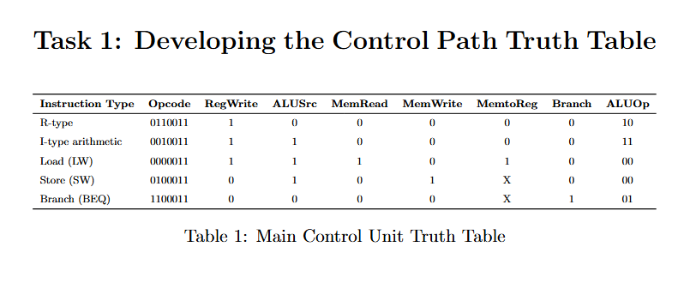
A truth table for the ALU control unit (ALUOp, funct3, funct7 as inputs).
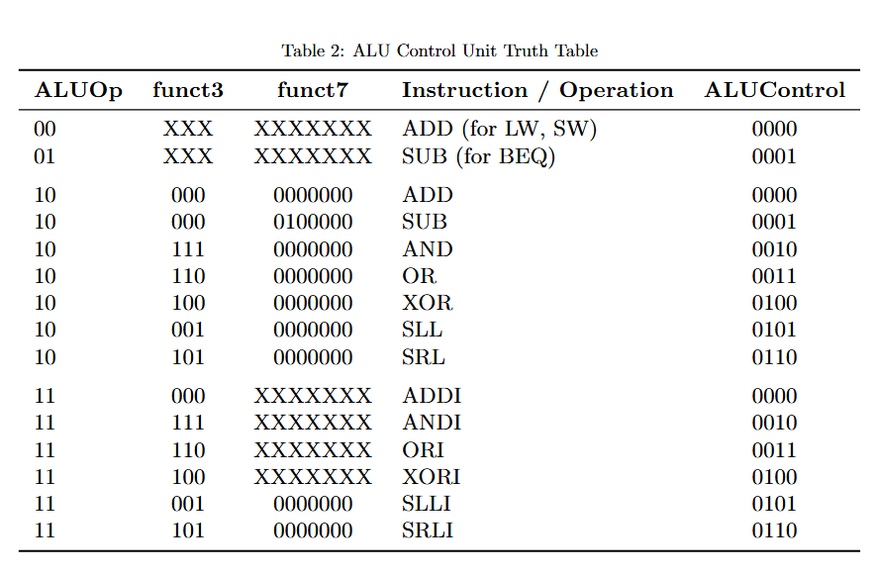

Task 2: Verilog Description and Testbench Development

Verilog source file for Main Control

module MainControl (

input wire [6:0] opcode,

output reg RegWrite,

output reg ALUSrc,

output reg MemRead,

output reg MemWrite,

output reg MemtoReg,

output reg Branch,

output reg [1:0] ALUOp

);

// ── Opcode constants ────────────────────────────────────────────

localparam R_TYPE = 7'b0110011; // ADD SUB SLL SRL AND OR XOR

localparam I_ALU = 7'b0010011; // ADDI

localparam I_LOAD = 7'b0000011; // LW LH LB

localparam S_TYPE = 7'b0100011; // SW SH SB

localparam B_TYPE = 7'b1100011; // BEQ

always @(*) begin

// ── Safe defaults (prevents unintended latches) ─────────────

RegWrite = 1'b0;

ALUSrc = 1'b0;

MemRead = 1'b0;

MemWrite = 1'b0;

MemtoReg = 1'b0;

Branch = 1'b0;

ALUOp = 2'b00;

case (opcode)

R_TYPE: begin

RegWrite = 1'b1;

ALUSrc = 1'b0;

MemRead = 1'b0;

MemWrite = 1'b0;

MemtoReg = 1'b0;

Branch = 1'b0;

ALUOp = 2'b10;

end

I_ALU: begin

RegWrite = 1'b1;

ALUSrc = 1'b1;

MemRead = 1'b0;

MemWrite = 1'b0;

MemtoReg = 1'b0;

Branch = 1'b0;

ALUOp = 2'b10;

end

I_LOAD: begin

RegWrite = 1'b1;

ALUSrc = 1'b1;

MemRead = 1'b1;

MemWrite = 1'b0;

MemtoReg = 1'b1;

Branch = 1'b0;

ALUOp = 2'b00;

end

S_TYPE: begin

RegWrite = 1'b0;

ALUSrc = 1'b1;

MemRead = 1'b0;

MemWrite = 1'b1;

MemtoReg = 1'b0; // don't-care → safe 0

Branch = 1'b0;

ALUOp = 2'b00;

end

B_TYPE: begin

RegWrite = 1'b0;

ALUSrc = 1'b0;

MemRead = 1'b0;

MemWrite = 1'b0;

MemtoReg = 1'b0; // don't-care → safe 0

Branch = 1'b1;

ALUOp = 2'b01;

end

default: begin

RegWrite = 1'b0;

ALUSrc = 1'b0;

MemRead = 1'b0;

MemWrite = 1'b0;

MemtoReg = 1'b0;

Branch = 1'b0;

ALUOp = 2'b00;

end

endcase

end

endmodule

Verilog source file for ALU Control

module ALUControl (

input wire [1:0] ALUOp, // From MainControl

input wire [2:0] funct3, // Instruction bits [14:12]

input wire [6:0] funct7, // Instruction bits [31:25]

output reg [3:0] ALUControl // To ALU32bit

);

always @(*) begin

case (ALUOp)

// ----------------------------------------------------------

// ALUOp = 00 → Force ADD (LW, LH, LB, SW, SH, SB)

// Address calculation: rs1 + sign_ext(imm)

// ----------------------------------------------------------

2'b00: ALUControl = 4'b0010; // ADD

// ----------------------------------------------------------

// ALUOp = 01 → Force SUB (BEQ)

// rs1 - rs2; if Zero=1 branch is taken

// ----------------------------------------------------------

2'b01: ALUControl = 4'b0110; // SUB

// ----------------------------------------------------------

// ALUOp = 10 → Decode funct3 / funct7

// Covers all R-type instructions and ADDI

// ----------------------------------------------------------

2'b10: begin

case (funct3)

3'b000: begin // ADD (funct7=0000000) / SUB (funct7=0100000) / ADDI

if (funct7 == 7'b0100000)

ALUControl = 4'b0110; // SUB

else

ALUControl = 4'b0010; // ADD / ADDI

end

3'b001: ALUControl = 4'b0100; // SLL

3'b101: ALUControl = 4'b0101; // SRL

3'b111: ALUControl = 4'b0000; // AND

3'b110: ALUControl = 4'b0001; // OR

3'b100: ALUControl = 4'b0011; // XOR

default: ALUControl = 4'b0010; // safe default → ADD

endcase

end

// ----------------------------------------------------------

// Default: force ADD (safe)

// ----------------------------------------------------------

default: ALUControl = 4'b0010;

endcase

end

endmodule

Testbench

module tb_control_path;

// ── MainControl ports ────────────────────────────────────────────

reg [6:0] opcode;

wire RegWrite, ALUSrc, MemRead, MemWrite, MemtoReg, Branch;

wire [1:0] ALUOp;

// ── ALUControl ports ─────────────────────────────────────────────

reg [2:0] funct3;

reg [6:0] funct7;

wire [3:0] ALUControl;

// ── ALU32bit ports ────────────────────────────────────────────────

reg [31:0] A, B;

wire [31:0] ALUResult;

wire Zero;

// ── Error counter ─────────────────────────────────────────────────

integer errors;

// ── DUT instantiations ────────────────────────────────────────────

MainControl u_main (

.opcode (opcode),

.RegWrite (RegWrite),

.ALUSrc (ALUSrc),

.MemRead (MemRead),

.MemWrite (MemWrite),

.MemtoReg (MemtoReg),

.Branch (Branch),

.ALUOp (ALUOp)

);

ALUControl u_alu_ctrl (

.ALUOp (ALUOp),

.funct3 (funct3),

.funct7 (funct7),

.ALUControl (ALUControl)

);

ALU32bit u_alu (

.A (A),

.B (B),

.ALUControl (ALUControl),

.ALUResult (ALUResult),

.Zero (Zero)

);

// ── Helper task: check control signals ───────────────────────────

task check_ctrl;

input [63:0] tag;

input exp_RegWrite, exp_ALUSrc, exp_MemRead, exp_MemWrite;

input exp_MemtoReg, exp_Branch;

input [1:0] exp_ALUOp;

input [3:0] exp_ALUControl;

begin

#5;

if (RegWrite !== exp_RegWrite) begin $display("FAIL [%s] RegWrite : got %b exp %b", tag, RegWrite, exp_RegWrite); errors=errors+1; end

if (ALUSrc !== exp_ALUSrc) begin $display("FAIL [%s] ALUSrc : got %b exp %b", tag, ALUSrc, exp_ALUSrc); errors=errors+1; end

if (MemRead !== exp_MemRead) begin $display("FAIL [%s] MemRead : got %b exp %b", tag, MemRead, exp_MemRead); errors=errors+1; end

if (MemWrite !== exp_MemWrite) begin $display("FAIL [%s] MemWrite : got %b exp %b", tag, MemWrite, exp_MemWrite); errors=errors+1; end

if (MemtoReg !== exp_MemtoReg) begin $display("FAIL [%s] MemtoReg : got %b exp %b", tag, MemtoReg, exp_MemtoReg); errors=errors+1; end

if (Branch !== exp_Branch) begin $display("FAIL [%s] Branch : got %b exp %b", tag, Branch, exp_Branch); errors=errors+1; end

if (ALUOp !== exp_ALUOp) begin $display("FAIL [%s] ALUOp : got %b exp %b", tag, ALUOp, exp_ALUOp); errors=errors+1; end

if (ALUControl !== exp_ALUControl) begin $display("FAIL [%s] ALUControl : got %b exp %b", tag, ALUControl, exp_ALUControl); errors=errors+1; end

end

endtask

// ── Helper task: check ALU arithmetic result ──────────────────────

task check_alu_result;

input [63:0] tag;

input [31:0] exp_result;

input exp_zero;

begin

if (ALUResult !== exp_result) begin

$display("FAIL [%s] ALUResult: got %0d exp %0d", tag, ALUResult, exp_result);

errors = errors + 1;

end else begin

$display("PASS [%s] ALUResult=%0d Zero=%b ALUControl=%b", tag, ALUResult, Zero, ALUControl);

end

if (Zero !== exp_zero) begin

$display("FAIL [%s] Zero flag: got %b exp %b", tag, Zero, exp_zero);

errors = errors + 1;

end

end

endtask

// ── Stimulus ─────────────────────────────────────────────────────

initial begin

errors = 0;

$dumpfile("waveform.vcd");

$dumpvars(0, tb_control_path);

A = 32'd20; B = 32'd7;

$display("==============================================");

$display(" CONTROL PATH VERIFICATION");

$display(" ALU32bit encoding used for ALUControl");

$display("==============================================");

// ── R-TYPE ADD ─────────────────────────────────────────────

// opcode=0110011 funct3=000 funct7=0000000

// Expect: RegWrite=1 ALUSrc=0 MemRead=0 MemWrite=0 MemtoReg=0 Branch=0 ALUOp=10

// ALUControl=0010 (ADD), ALUResult=27, Zero=0

opcode=7'b0110011; funct3=3'b000; funct7=7'b0000000;

check_ctrl("ADD ",1,0,0,0,0,0,2'b10,4'b0010);

check_alu_result("ADD ",32'd27,1'b0);

// ── R-TYPE SUB ─────────────────────────────────────────────

// opcode=0110011 funct3=000 funct7=0100000

// ALUControl=0110 (SUB), ALUResult=13, Zero=0

opcode=7'b0110011; funct3=3'b000; funct7=7'b0100000;

check_ctrl("SUB ",1,0,0,0,0,0,2'b10,4'b0110);

check_alu_result("SUB ",32'd13,1'b0);

// ── R-TYPE SUB equal (Zero flag test) ──────────────────────

A=32'd10; B=32'd10;

opcode=7'b0110011; funct3=3'b000; funct7=7'b0100000;

check_alu_result("SUB_ZERO",32'd0,1'b1);

A=32'd20; B=32'd7;

// ── R-TYPE SLL ─────────────────────────────────────────────

// ALUControl=0100 (SLL), ALUResult = 20 << 7 = 2560

opcode=7'b0110011; funct3=3'b001; funct7=7'b0000000;

check_ctrl("SLL ",1,0,0,0,0,0,2'b10,4'b0100);

check_alu_result("SLL ",32'd2560,1'b0);

// ── R-TYPE SRL ─────────────────────────────────────────────

// ALUControl=0101 (SRL), ALUResult = 20 >> 7 = 0

opcode=7'b0110011; funct3=3'b101; funct7=7'b0000000;

check_ctrl("SRL ",1,0,0,0,0,0,2'b10,4'b0101);

check_alu_result("SRL ",32'd0,1'b1);

// ── R-TYPE AND ─────────────────────────────────────────────

// ALUControl=0000 (AND), ALUResult = 20&7 = 4

opcode=7'b0110011; funct3=3'b111; funct7=7'b0000000;

check_ctrl("AND ",1,0,0,0,0,0,2'b10,4'b0000);

check_alu_result("AND ",32'd4,1'b0);

// ── R-TYPE OR ──────────────────────────────────────────────

// ALUControl=0001 (OR), ALUResult = 20|7 = 23

opcode=7'b0110011; funct3=3'b110; funct7=7'b0000000;

check_ctrl("OR ",1,0,0,0,0,0,2'b10,4'b0001);

check_alu_result("OR ",32'd23,1'b0);

// ── R-TYPE XOR ─────────────────────────────────────────────

// ALUControl=0011 (XOR), ALUResult = 20^7 = 19

opcode=7'b0110011; funct3=3'b100; funct7=7'b0000000;

check_ctrl("XOR ",1,0,0,0,0,0,2'b10,4'b0011);

check_alu_result("XOR ",32'd19,1'b0);

// ── ADDI ───────────────────────────────────────────────────

// opcode=0010011 funct3=000 funct7=X (imm bits - treated as 0 here)

// ALUControl=0010 (ADD), ALUResult=27

opcode=7'b0010011; funct3=3'b000; funct7=7'b0000000;

check_ctrl("ADDI ",1,1,0,0,0,0,2'b10,4'b0010);

check_alu_result("ADDI ",32'd27,1'b0);

// ── LOAD (LW) ──────────────────────────────────────────────

// opcode=0000011

// ALUOp=00 → ALUControl=0010 (ADD, address = rs1 + imm)

// RegWrite=1 MemRead=1 ALUSrc=1 MemtoReg=1

opcode=7'b0000011; funct3=3'b010; funct7=7'b0000000;

check_ctrl("LW ",1,1,1,0,1,0,2'b00,4'b0010);

check_alu_result("LW_ADDR ",32'd27,1'b0); // address = 20+7

// ── STORE (SW) ─────────────────────────────────────────────

// opcode=0100011

// ALUOp=00 → ALUControl=0010 (ADD, address = rs1 + imm)

// RegWrite=0 MemWrite=1 ALUSrc=1

opcode=7'b0100011; funct3=3'b010; funct7=7'b0000000;

check_ctrl("SW ",0,1,0,1,0,0,2'b00,4'b0010);

check_alu_result("SW_ADDR ",32'd27,1'b0);

// ── BEQ (not equal) ────────────────────────────────────────

// opcode=1100011

// ALUOp=01 → ALUControl=0110 (SUB), Zero=0 → branch NOT taken

opcode=7'b1100011; funct3=3'b000; funct7=7'b0000000;

check_ctrl("BEQ_NE ",0,0,0,0,0,1,2'b01,4'b0110);

check_alu_result("BEQ_NE ",32'd13,1'b0); // 20-7=13, Zero=0

// ── BEQ (equal - branch taken) ─────────────────────────────

A=32'd15; B=32'd15;

opcode=7'b1100011; funct3=3'b000; funct7=7'b0000000;

check_alu_result("BEQ_EQ ",32'd0,1'b1); // 15-15=0, Zero=1 → branch taken

// ── Summary ────────────────────────────────────────────────

#10;

$display("==============================================");

if (errors == 0)

$display(" ALL %0d TESTS PASSED", 24);

else

$display(" %0d TEST(S) FAILED", errors);

$display("==============================================");

$finish;

end

endmodule

Simulation waveform screenshots highlighting all control signal transitions.

Waveforms and explanation:

Segment 1: opcode = 0x33 → R-TYPE (0–~25 ns)

This covers ADD, SUB, SLL, SRL, AND, OR, XOR — funct3 cycles through 0,1,5,7,6,4

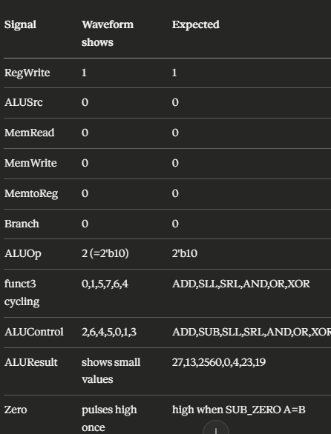

ADD:
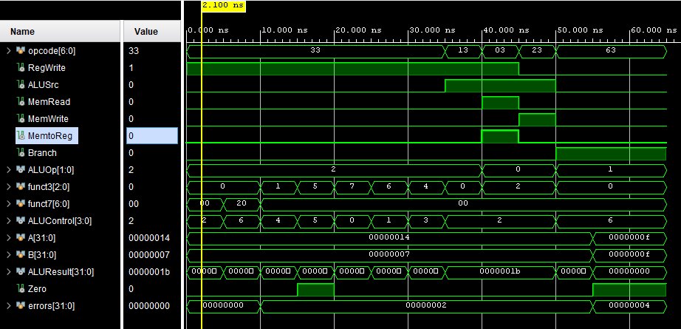

SUB:
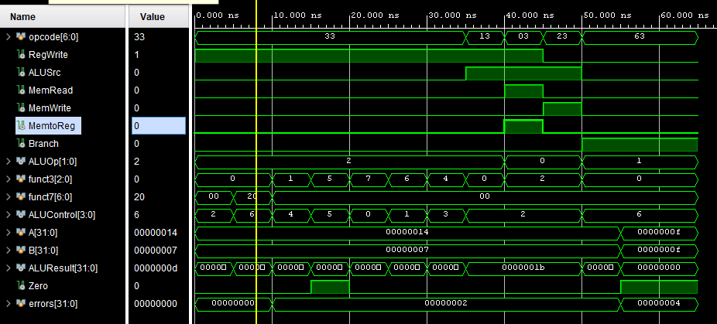

SLL:
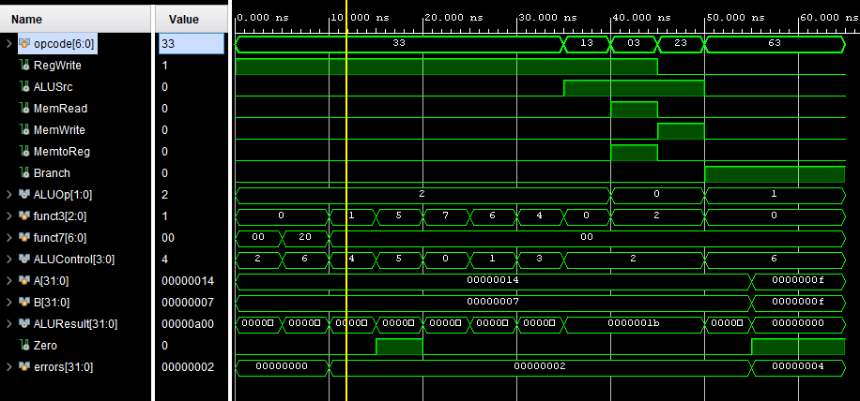

SRL:
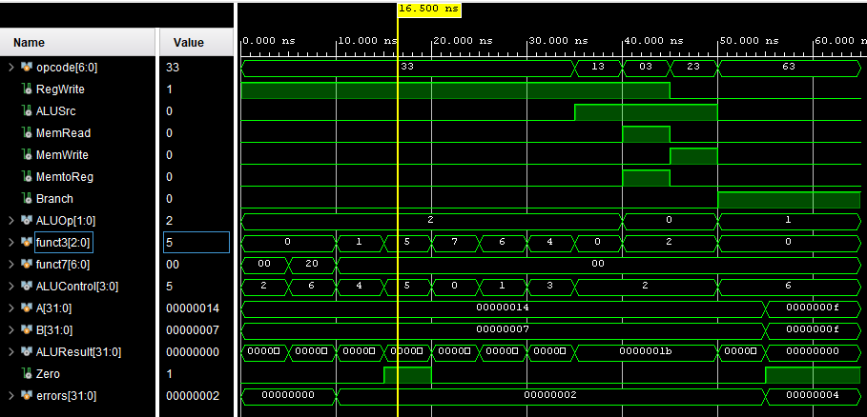

AND:
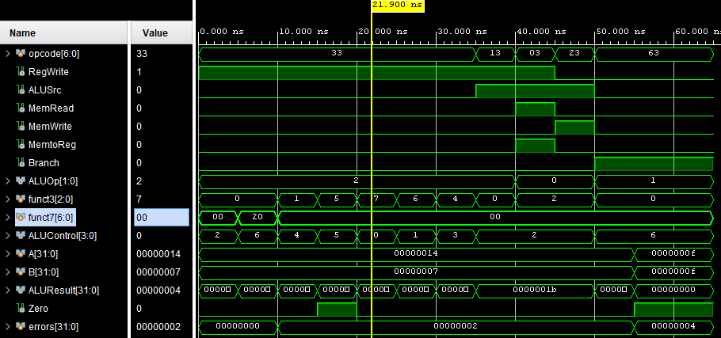

OR:
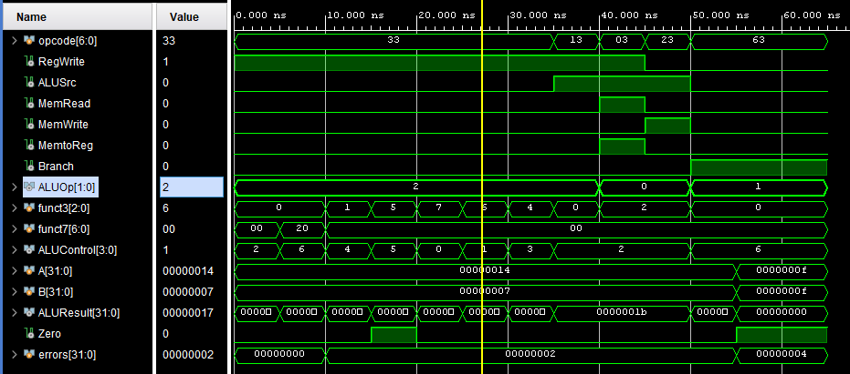

XOR:
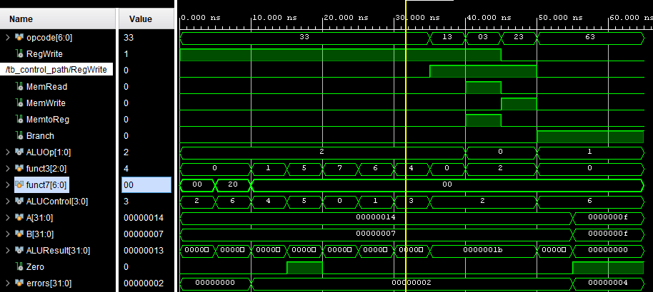

Segment 2: opcode = 0x13 → ADDI (~25–33 ns)
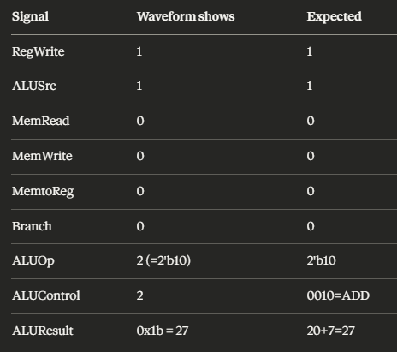
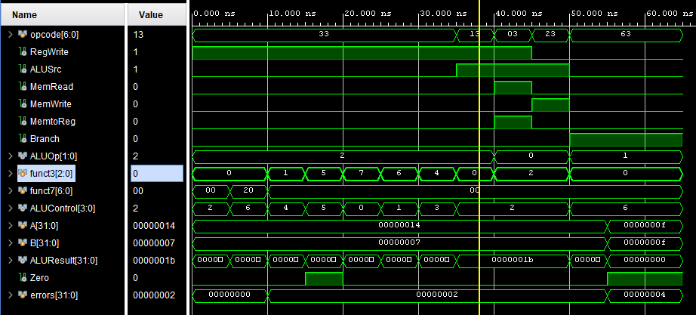

Segment 3: opcode = 0x03 → LOAD (~33–38 ns)
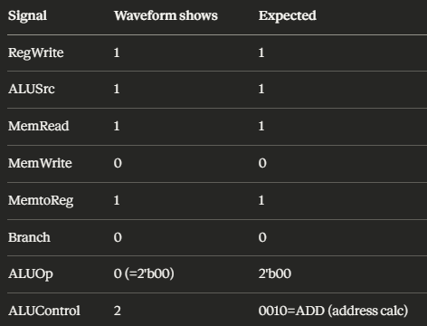
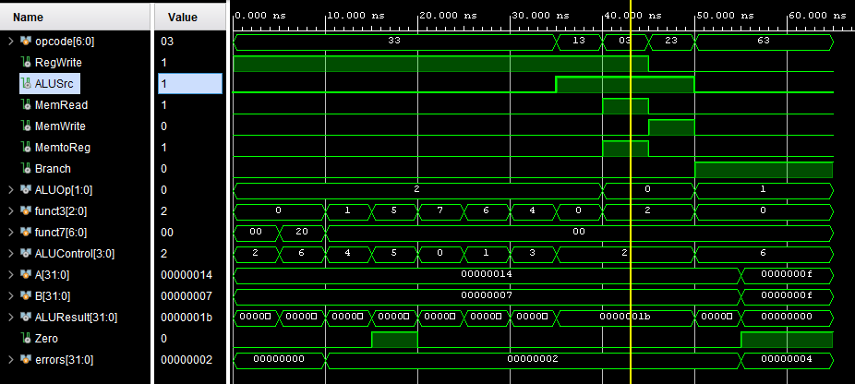

Segment 4: opcode = 0x23 → STORE (~38–46 ns)
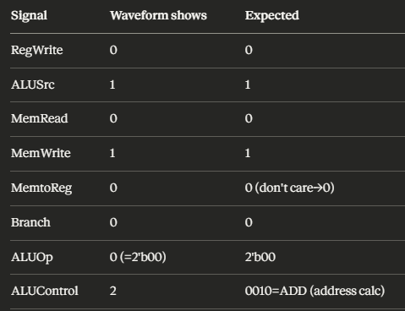

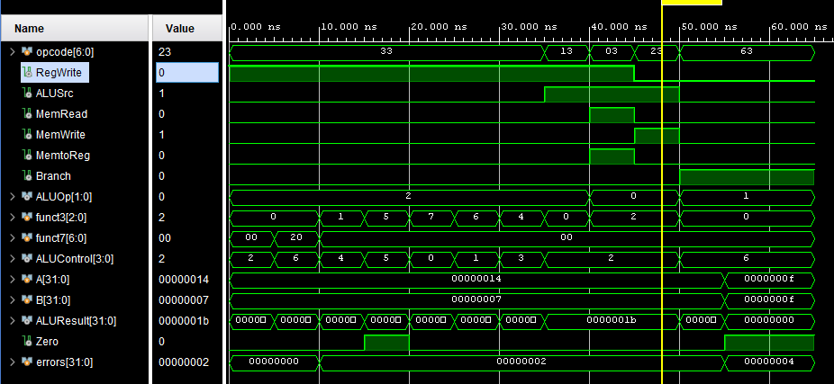

Segment 5: opcode = 0x63 → BEQ (~46–60 ns)
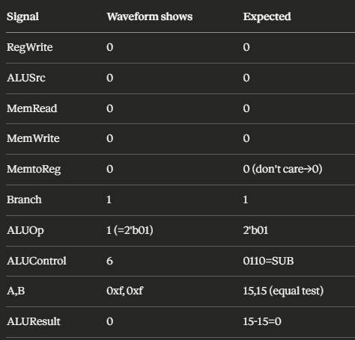
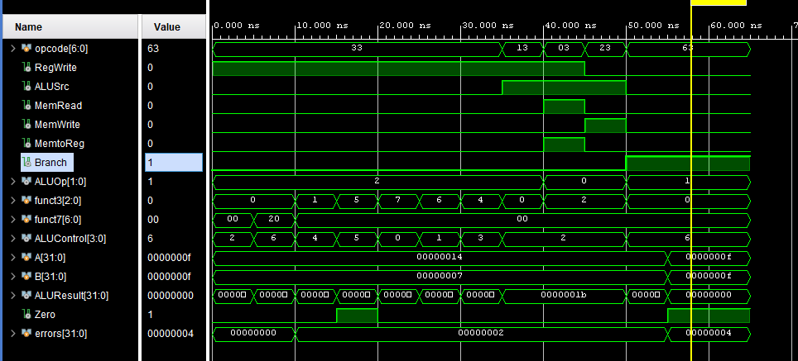

Task 3: FPGA Synthesis and RTL Analysis

Deliverables
Note: The switch interface, button debouncing module, and LED interface must be re used from Lab 5.

RTL schematic screenshots

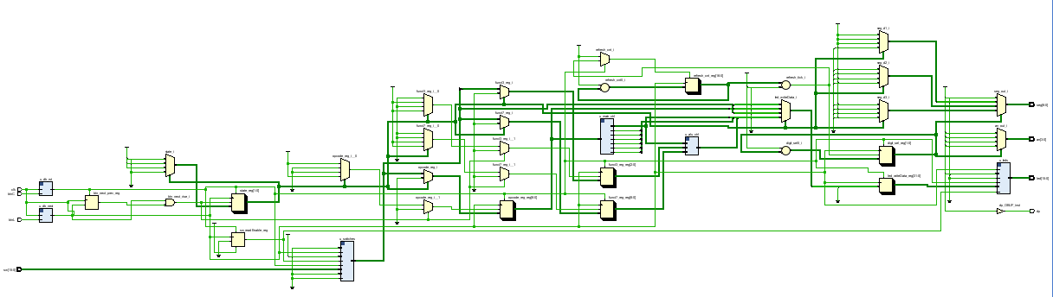

Demonstration of FPGA operation

Led mapping:

LEDS
0 | Register Write
1 | Mem read
2 | Mem Write
3 | Alu SRC
4 | Mem to Reg

5
6 - 9 | ALU control
10-11 | ALU op

SW 0-6: OPCODE
SW 7-9: Fuct 3
SW 10: Function 7

REGISTER WRITE:

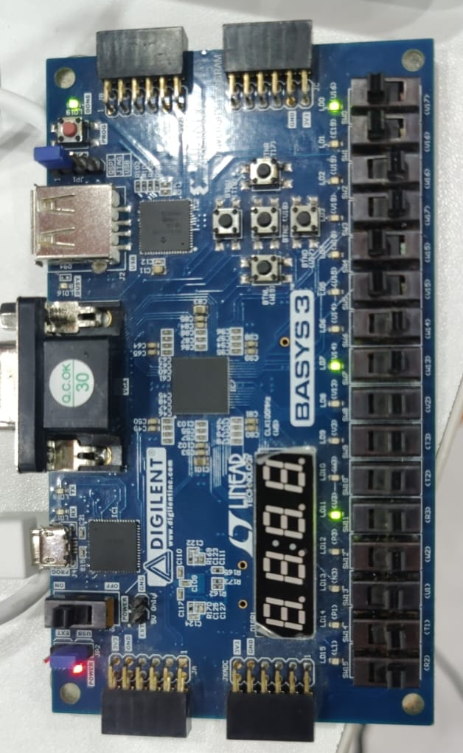

LOAD REGISTER:
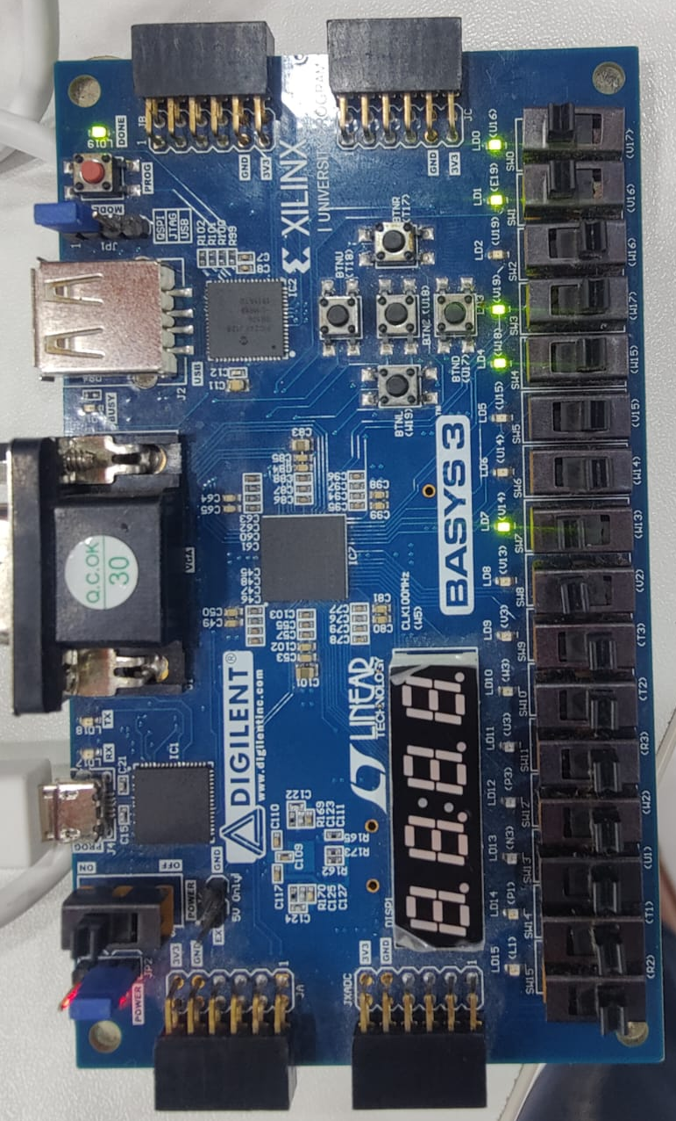

Assessment Rubric
Lab 9: Design and FPGA Implementation of the Control Path for a Single-Cycle RISC-V Processor

Name: | Student ID: | Section:

Points Distribution

 | Task No. | LR 2 (Code) | LR 5 (Results) | LR 10  (Analysis)
In-Lab | Task 1 | - | - | /20
In-Lab | Task 2 | /20 | /15 | -
In-Lab | Task 3 | /10 | /15 | -
Total Points |  | /30 | /30 | /20
CLO Mapped |  | CLO 1

Affective Domain Rubric |  | Points | CLO Mapped
AR7 | Report Submission & Git Upload | /10 & /10 | CLO 1

CLO | Total Points | Points Obtained
1 | 100
Total | 100

For description of different levels of the mapped rubrics, please refer to the Lab Evaluation Assessment Rubrics and Affective Domain Assessment Rubrics

